Student Contract for Mr. Waterman’s Classes
- I have watched Mr. Waterman’s video about supplies.
- I promise to be a responsible student.
- I promise to take care of all of my notebooks and workbooks.
- I understand I will only get 1 set of notebooks and 1 set of workbooks.
- If I lose my notebooks and workbooks, I will have to use my own notebook or notebook paper.
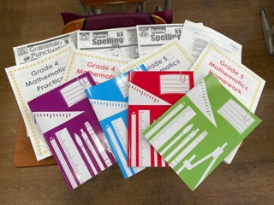

Name ________________________ Class _____-______ No. _____
Date ______________________
Teacher _______________________________
Date ______________________

